After Storing and Running the Script:

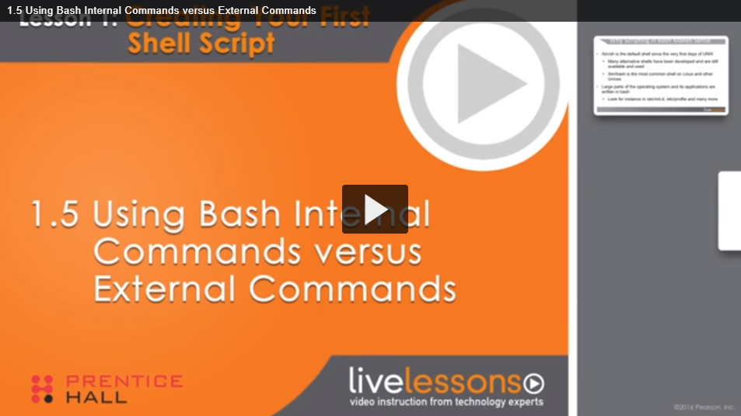

Transcript

- In a script you can use Bash internal

and external commands.

And it's important if youare going to write scripts

that you know a littlebit about the difference

between those two.

An internal command ispart of the Bash shell.

In the advantages, that itdoes not have to be loaded

from disk and therefore is faster.

If you want to get an overview of all

internal commands, you can type help

on the Bash prompt to get a list of all

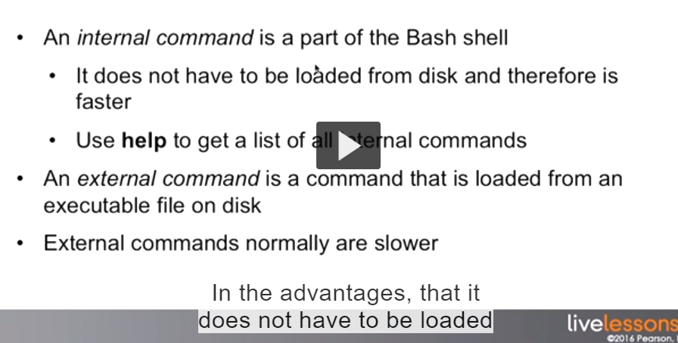



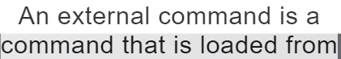



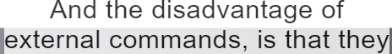



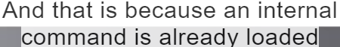







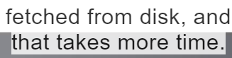

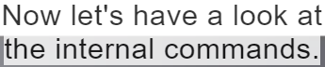

If you type help you get a list of all the internal commands are available

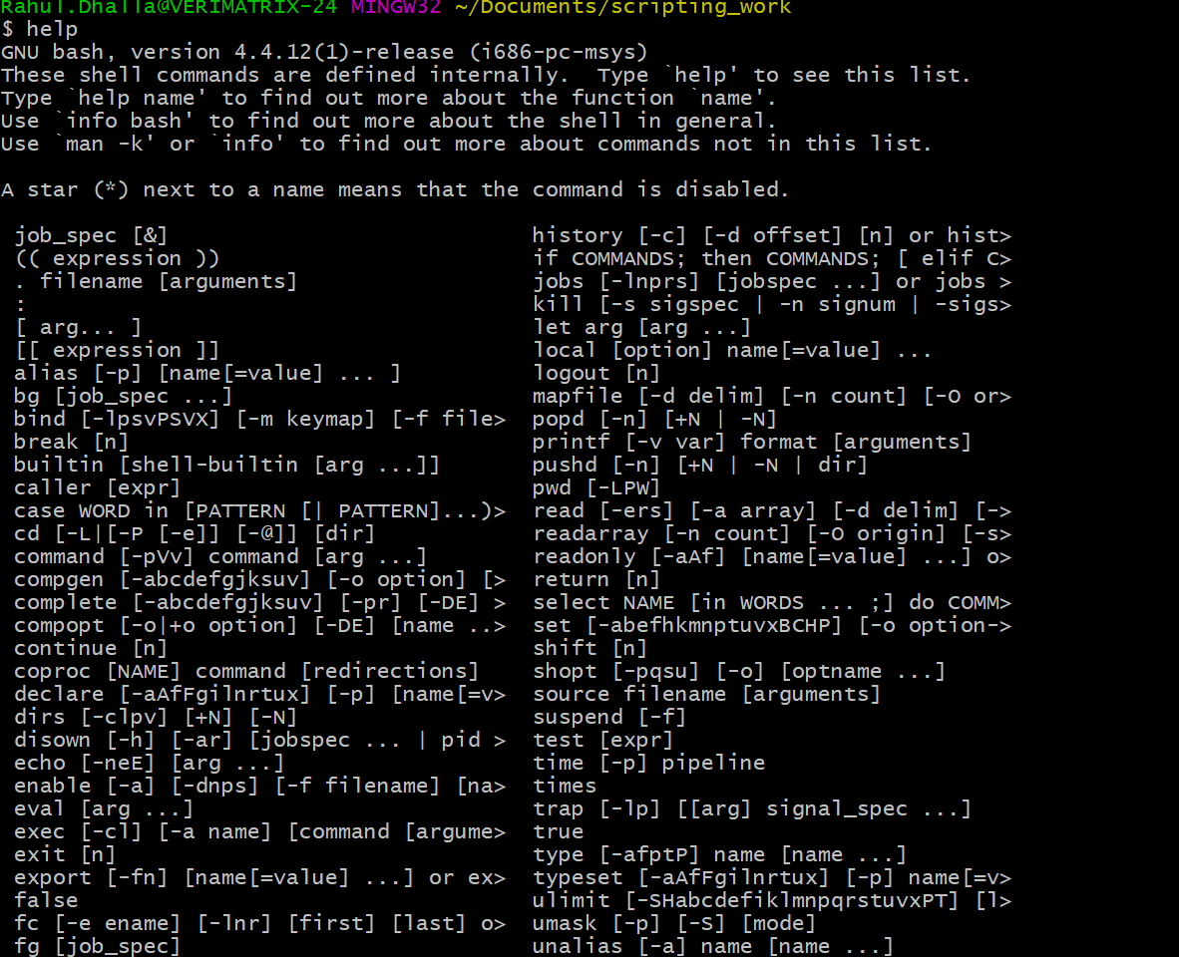

Es de kehn da malba hega kuj (eh commands vi executable hi ne) so .Jido bash load hunda uhdo hi eh executable vi load hojandiya va

We will see many internal commands later on this course when we go deeper through different items that can be used in the bash script





You will see the command “test” is in internal command that is interesting because when we did which test

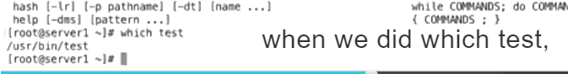

















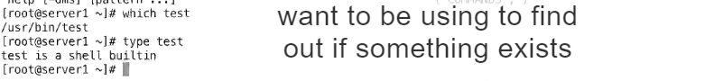







Shell built in means pata lag gya hoyega





Use type instead of which to find out

Now there is a conflict between internal and external command

The internal command always win.

So the bash shell will first execute the internal commands





External commands.

SO let me demo this



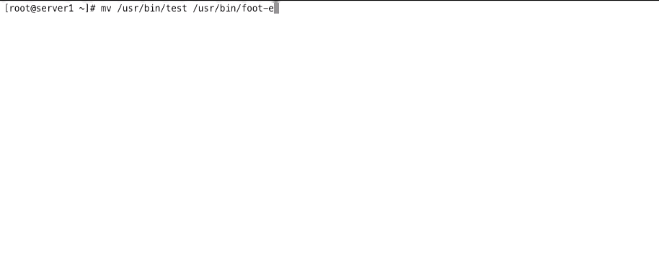







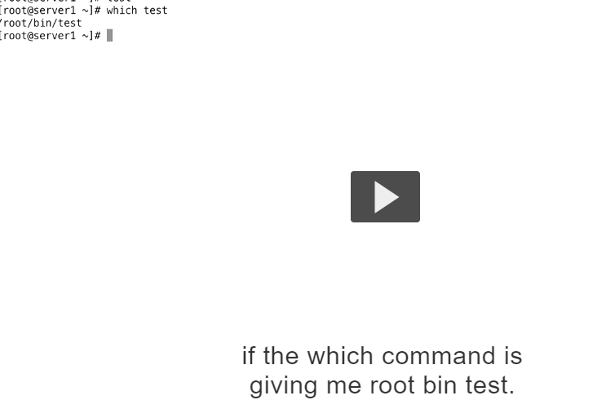











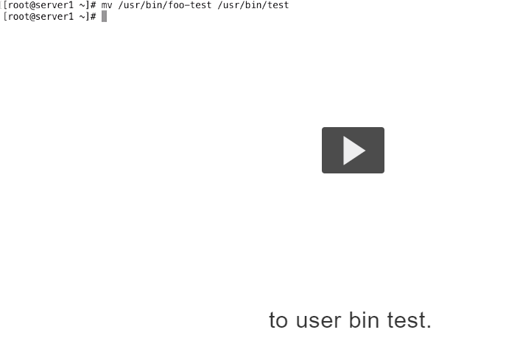





/usr/bin/test is external command that means jehri assi file diiiti si o hegi usnu kehnde aa external file cho load karo



## Transcript

- When you are writing scripts, there are different

ways to find help about scripting components.

Even if you have done everything that

we are covering in this course,

you still might want to look at the things

when you are applying them.

The first way of getting help is by using man bash.

That's a man bates of the bash command.

It contains all the help that you need,

but it is very large.

If you are looking for

information about bash in general,

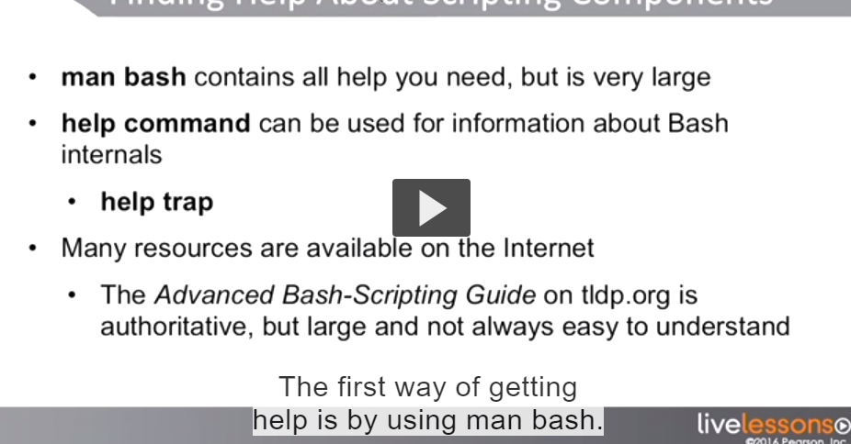



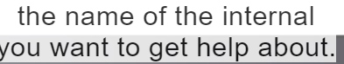

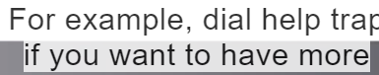

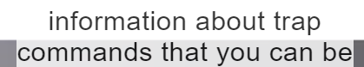

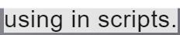

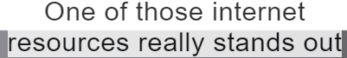

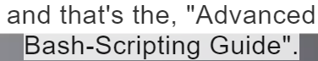



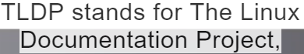

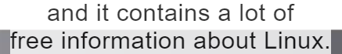

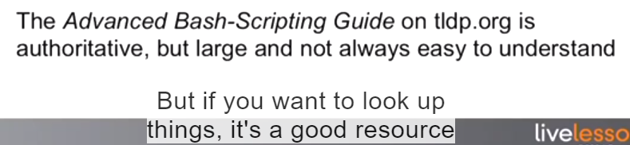

To get information about scripting

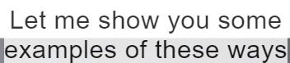

Of getting help



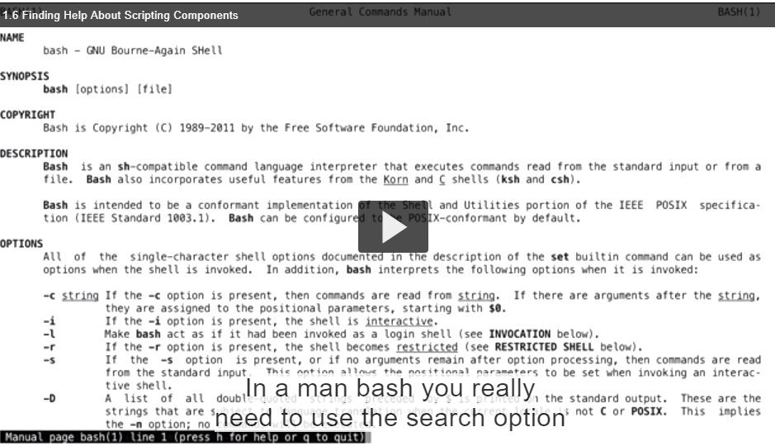

To look for the specific option that you want to know more about



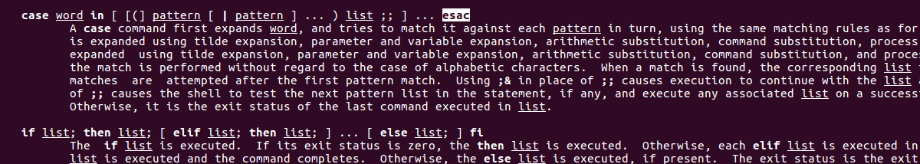



About a case statement and if you go further you can see the explanation about the case statement right here



Man bash itself

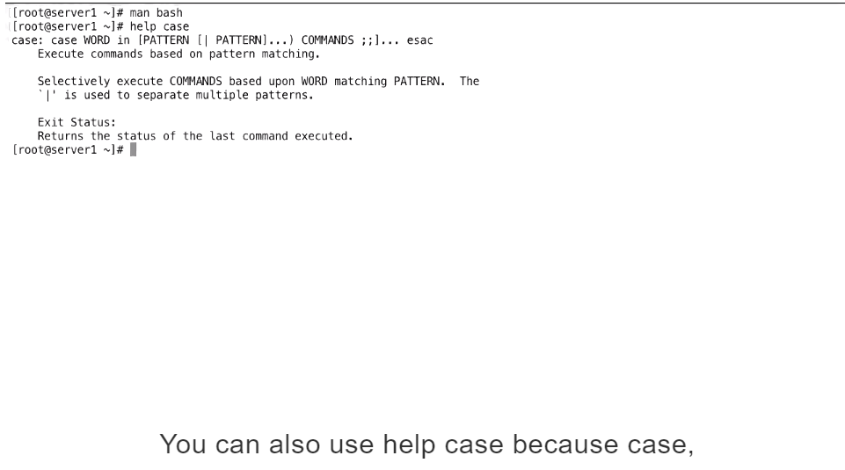















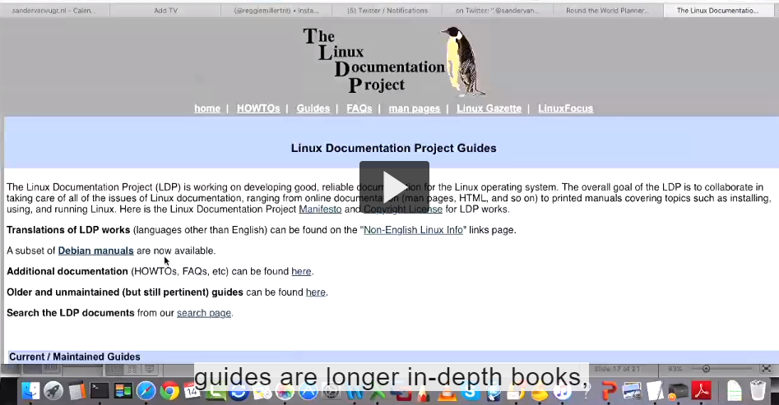

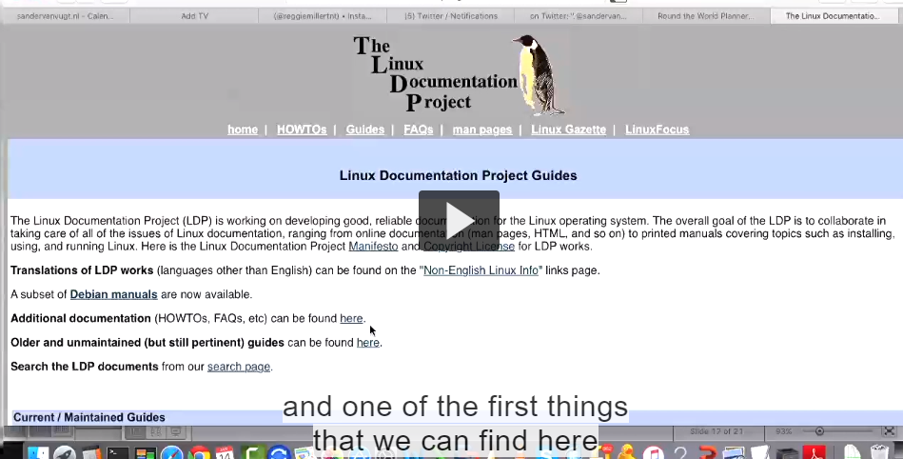

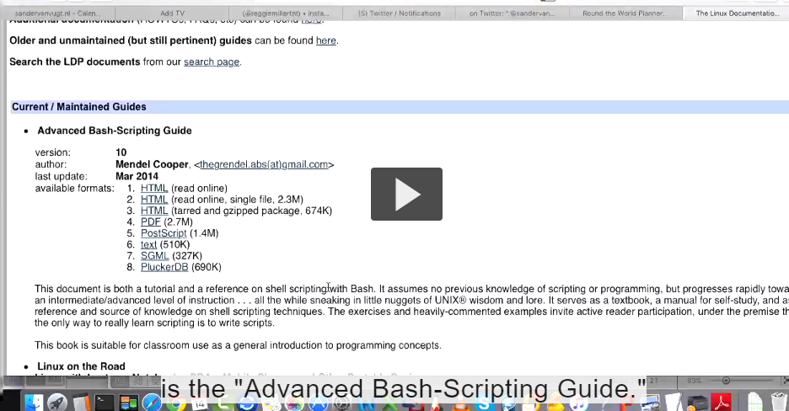



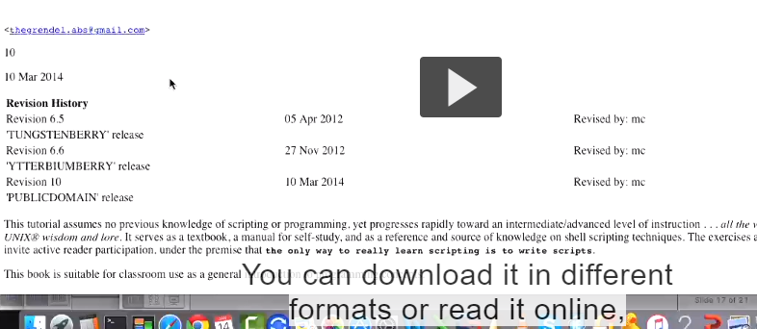







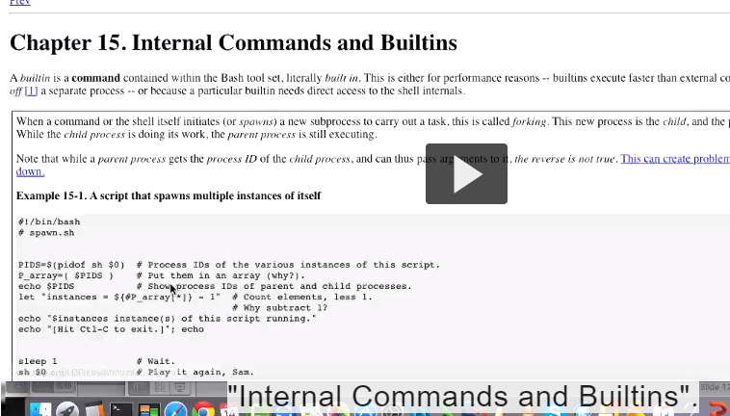

It shows you about internal commands



## Transcript

- So we have covered all of the basics

of shell scripting right now,

let's have a look at exercise one.

As I've mentioned before,

this course containsan exercise at the end

of every single lesson,

and the idea is that I'm going to explain

what I want you to do in the exercise,

and every exercise is followed by

an exercise explanation.

Let's have a look at the exercise.

So in exercise one,

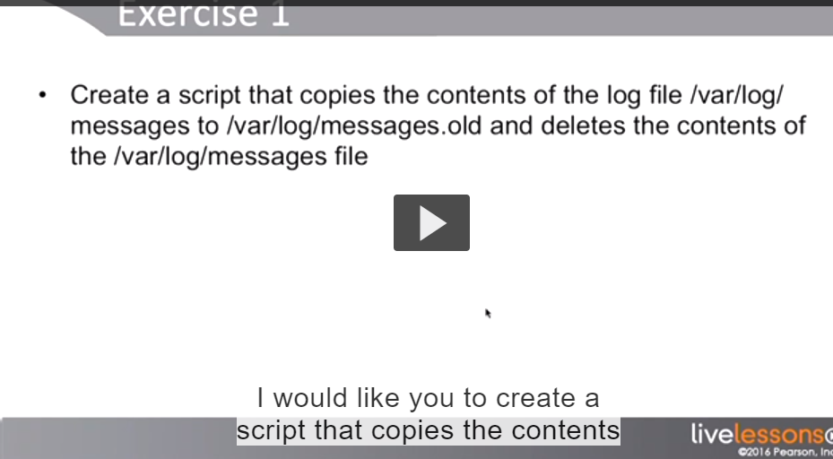



## Transcript

- Now let's have a lookat possible solutions

for exercise one.

Before I'm even showing you the solution,

I just want to mention that this is just

a solution.

Different solutions do exist,when you create scripts.

And normally if I'm givinga scripting assignment

to ten different people, I see at least

three or four different approaches



Its doesn’t mean its wrong









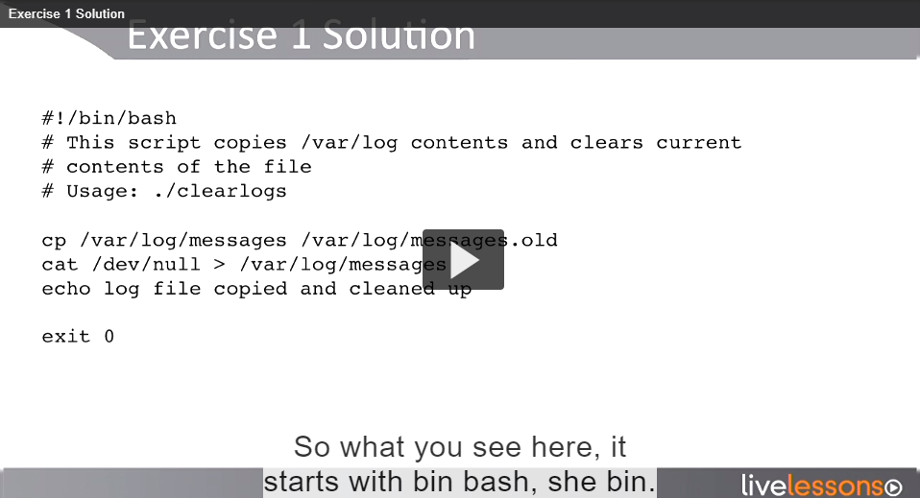

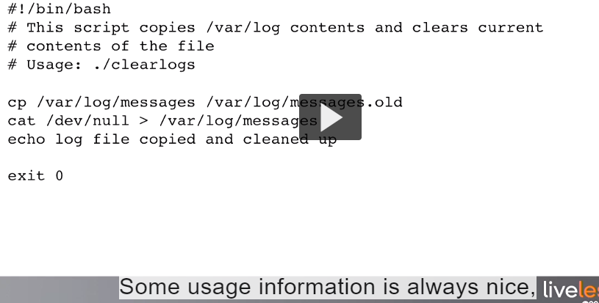

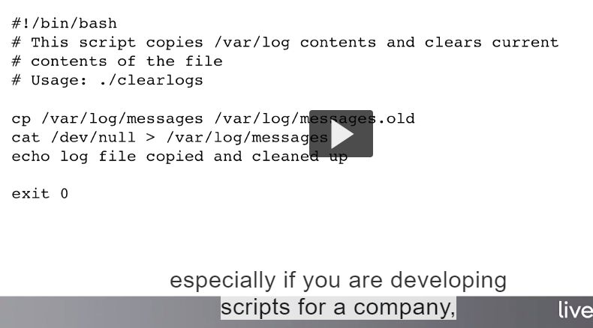







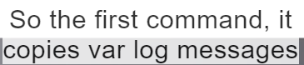

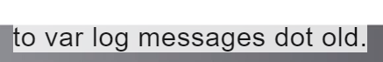







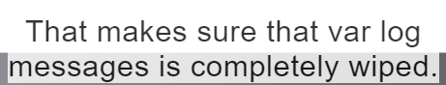

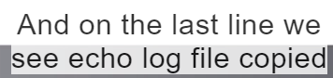

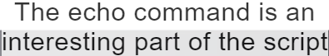

































Why he doesn’t use .sh in file (kuch ta logic hain)





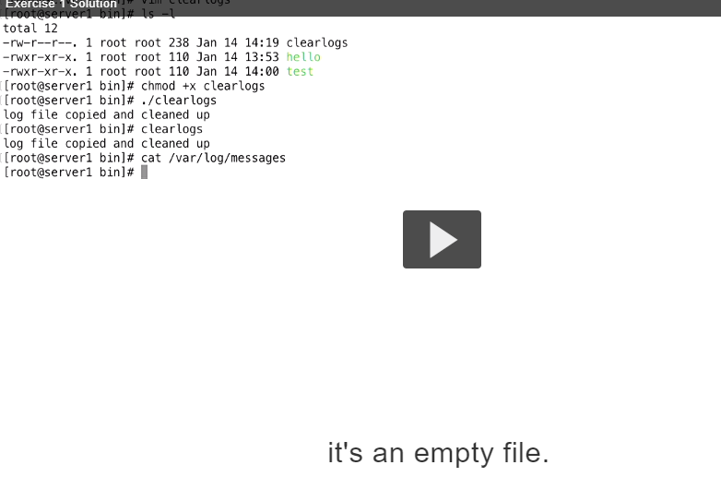

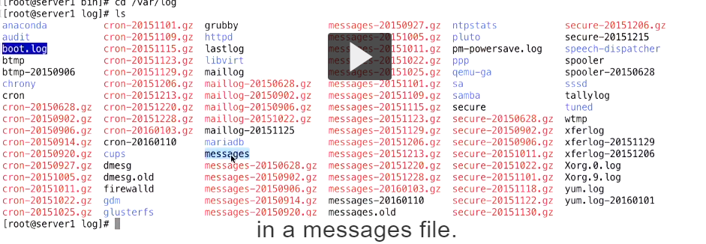

Script is succeddful this is end of lesson 1

Lesson 2:



## Transcript

- Lesson Two: Working withVariables and Parameters.

Welcome to lesson two,this is an important lesson

that teaches you how to work with dynamic

content in a shell script.

You'll learn how towork with variables and

all the techniques toinclude dynamically generated

data in a shell script.

You'll also learn aboutparameters and subshells and

how they affect your variables.

Another important topiccovered in this lesson

that every scriptist shouldknow about is quoting..

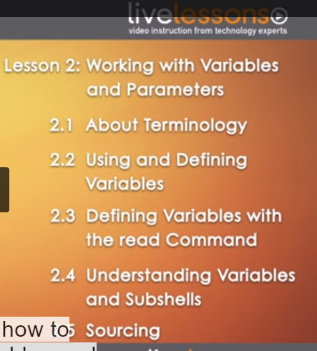

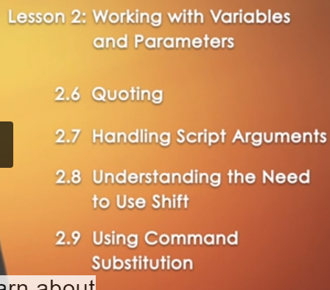

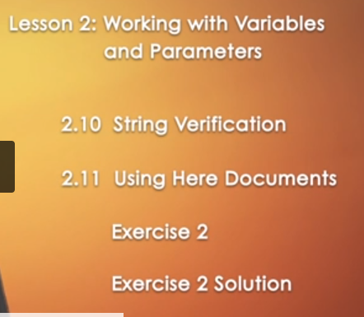

## Transcript

- Before we start talkingabout variables and parameters,

I want to spend some timetalking about terminology

because a lot of terminologyis often misinterpreted

when dealing with scripts.

I want to make sure that weall agree on the terminology.

So first there's the argument.

That is anything that canbe used after a command.

So in the example, ls -l/etc,

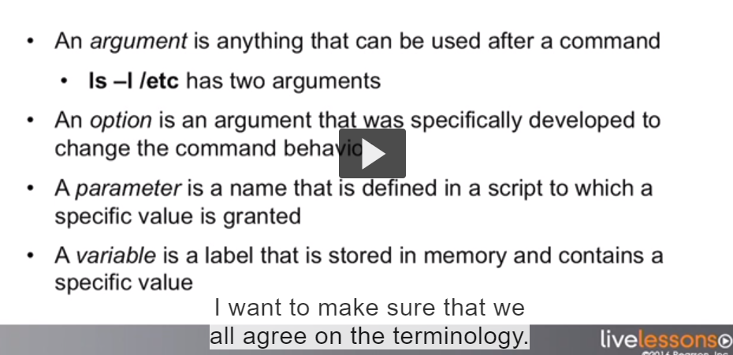





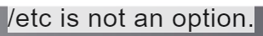



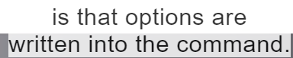









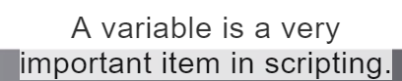











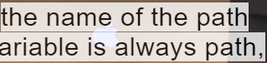



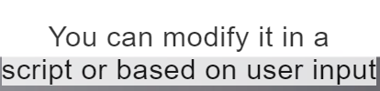



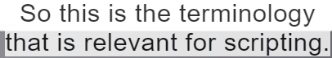





What we were talking about



## Transcript

- Now let's talk about usingand defining variables.

So, variables are used tomake a script flexible.

They allow for dynamic scripts

that can easily be modifiedto act on different values.

Let's have a look at an example.

In here you can see the variable LOGFILE

being defined as /var/log/messages.

Notice that I'm using uppercase

to define a variable.

I like using uppercaseto define variables.

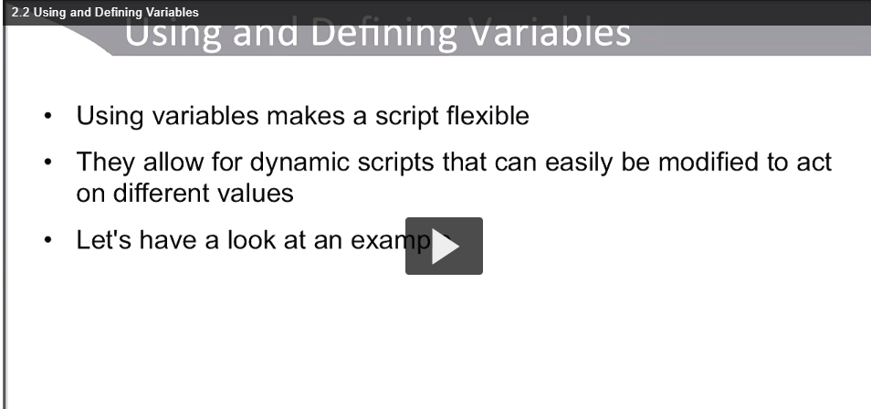

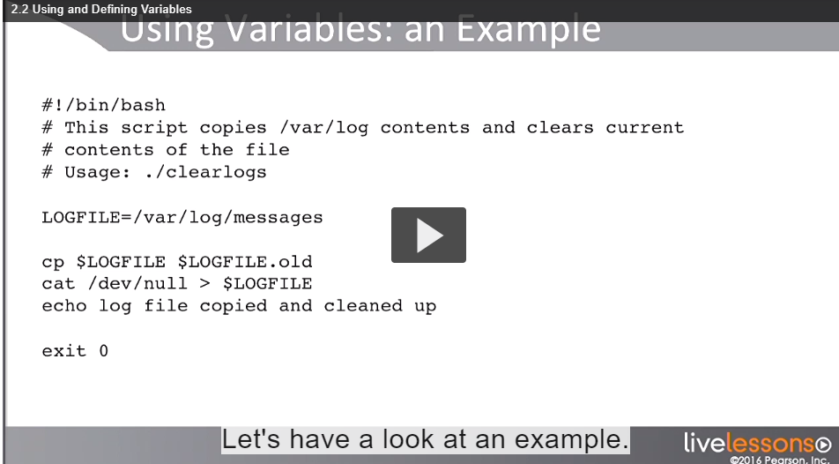

Notice I am usng uppercase to define a variable

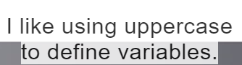





You can use lowercase







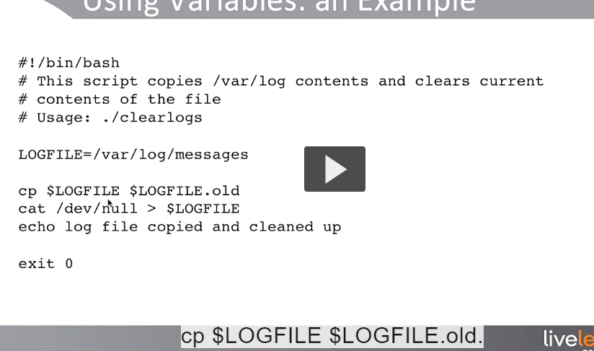

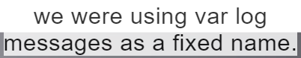







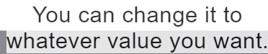



The next thing figure out is how to define a variable.

1.Defining in the script itself is one option,But there are other options as well









1.Keep all the variables together because it makes easier to work with the contents of the script and that is also what you seein most of the script syou will ever be working with. What people also see with the variables on some occasions are defined in an includes script.

So that is a separate script.when the code of a specific script



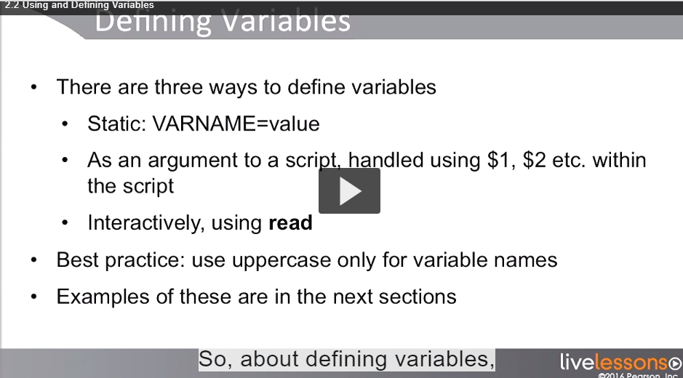

1.First option is Static you can do in script or you can read from command line

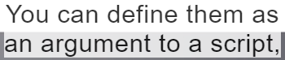

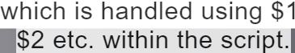



All of the above discussed shortly.

Best Practice: Use the Uppercase only for variable names

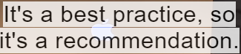



I am giving you simple example to defining a variable I am show you how you can do from command line



To request a current value of a variable





It gives me empty line which means the variable currently is not set

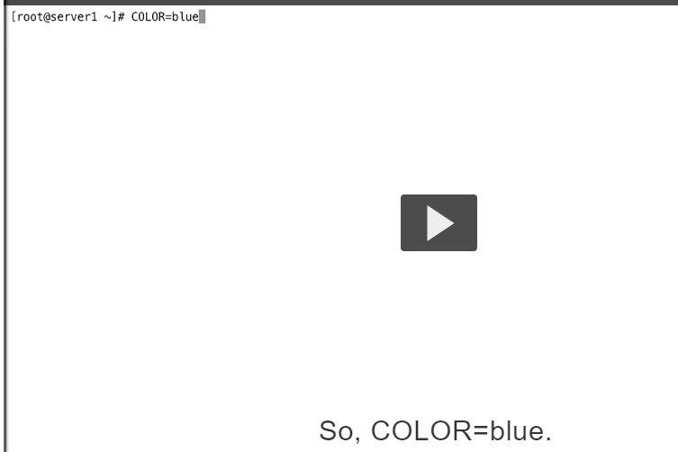

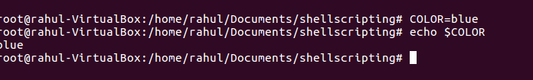

This is from command line.

You should notice its gone if you close the session or as soon as you start a subshell

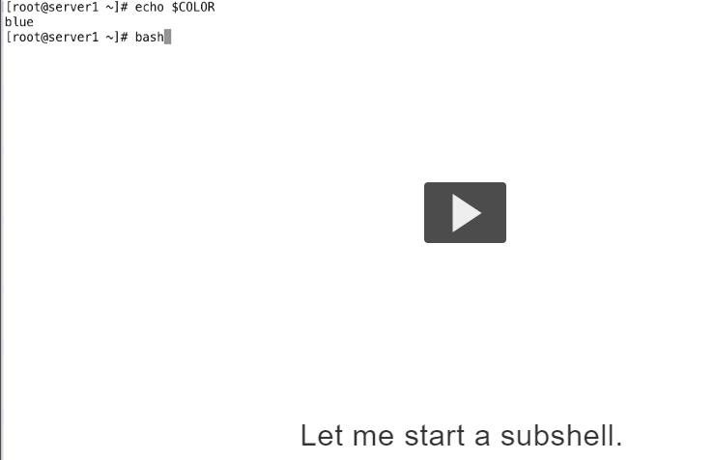





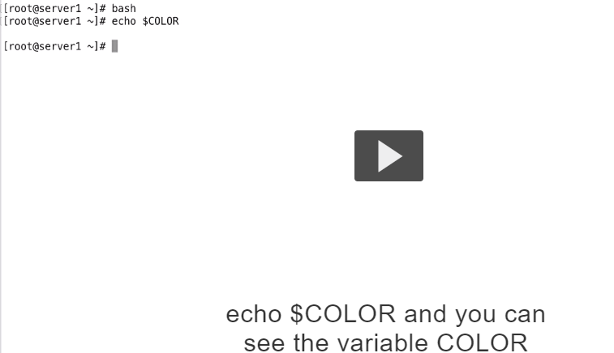

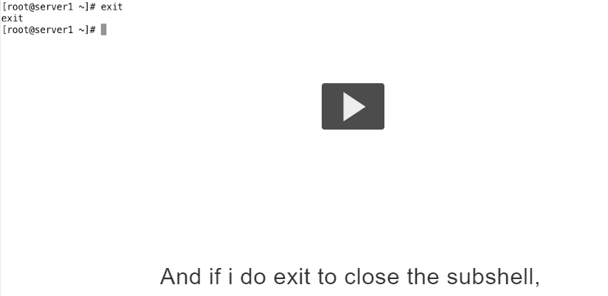

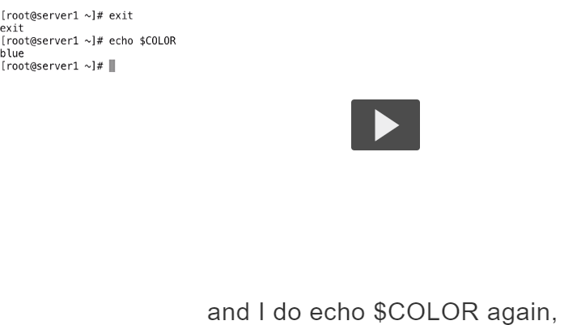







Export use karo

Agar chahuhnde subshell ch vi aave hona ki aa subshell child process hega so environment variable inherit hojande ne .

Export COLOR=blue

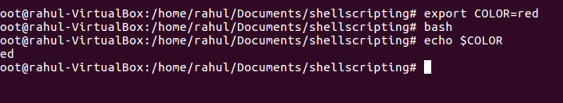

Verified.

You can seen the variable is now been reset.so if you would design it gain it will be lost and if you start a subshell.

So if you want varibles to be available outside of the script its good idea to use export.

Je within the shell where script is running then you don’t need to use export.



## Transcript

- Now let's have a look at how we can

define variables using read.

Read is a command that you can use in a shell script

and this script is showing you an example.

So the core code of the script

is echo which process do you want to kill?

So we are asking something to the user.

Next we can see read.

Read followed by the name of the variable

that is going to be filled with the answer

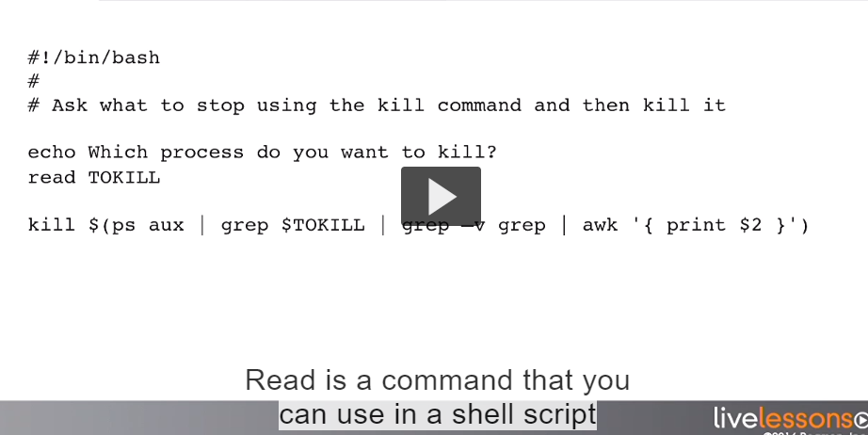



So the variable TOKILL IS USED IN THIS CASE AND it will be defined when the user is typing his answer

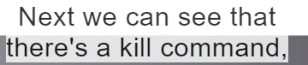

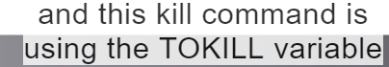

In what it is doing.

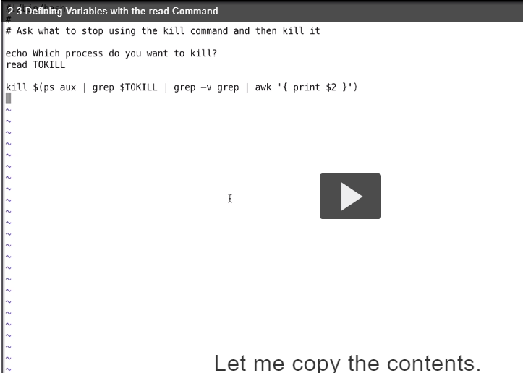

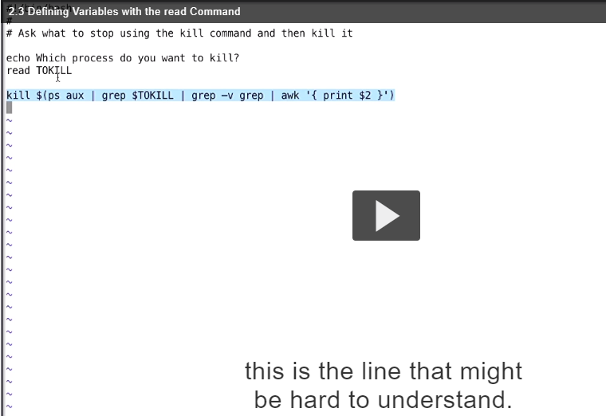

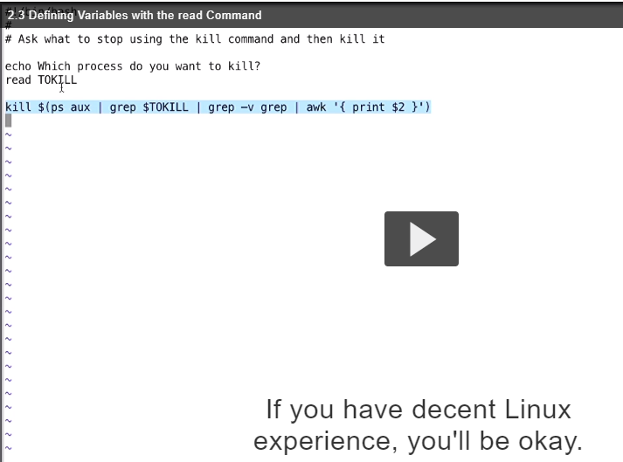



So what we are going to do.we are going to use the KILL command that is linux kill command

what I am going to do is use the

















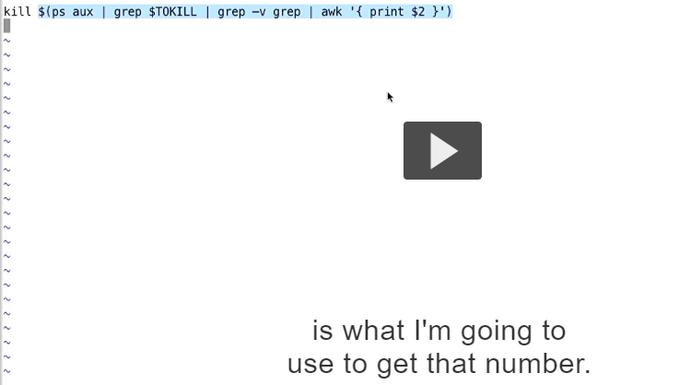



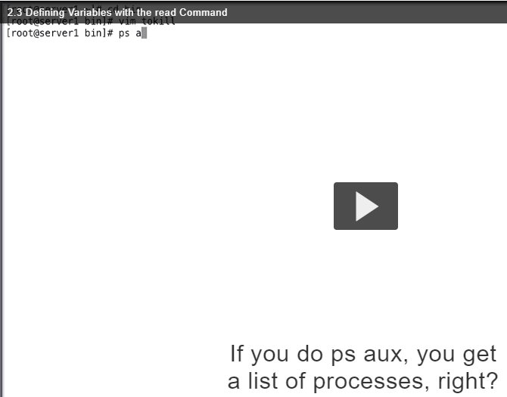

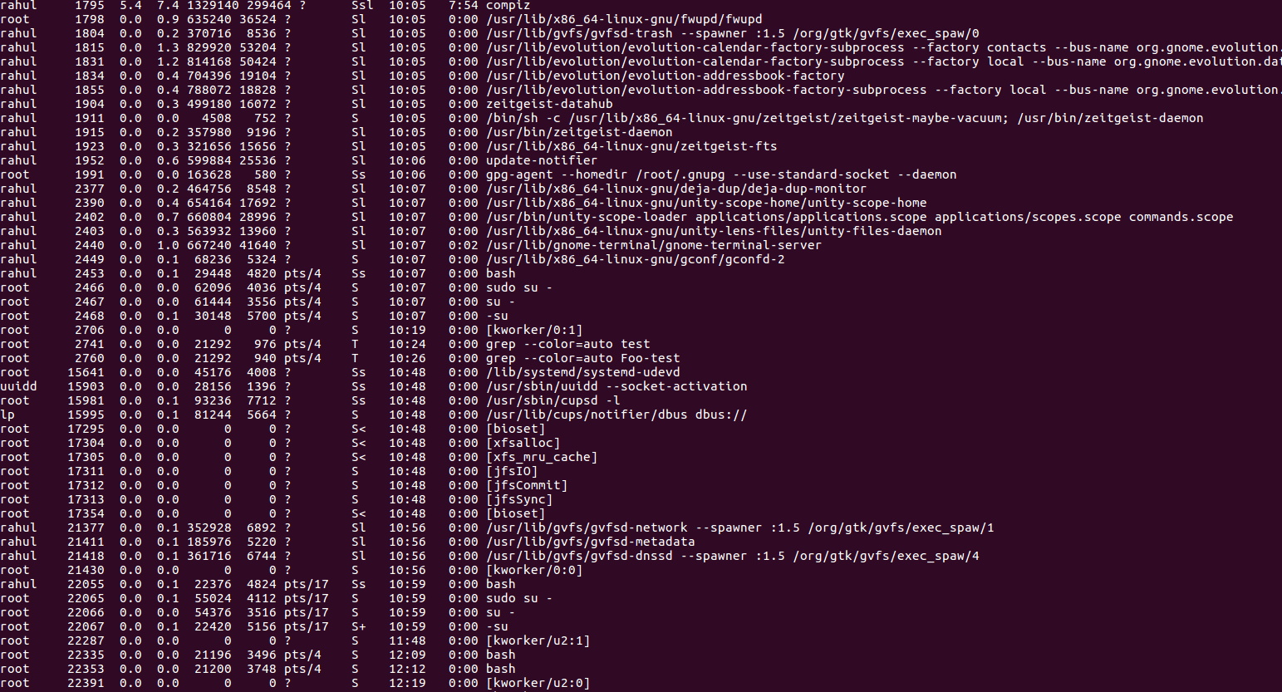

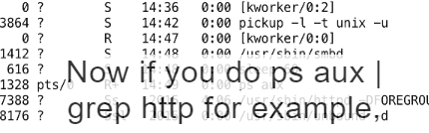



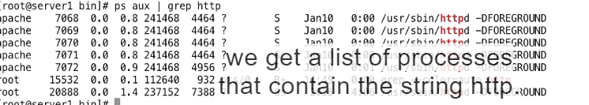





Process id

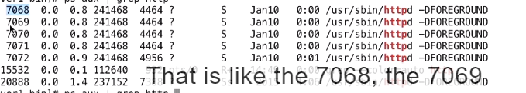





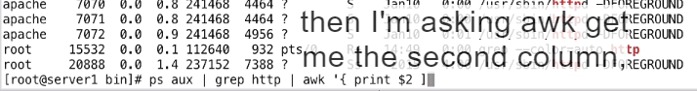

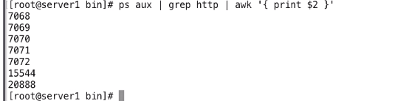



Which is LIST OF PIDS.Now this is almost what we need

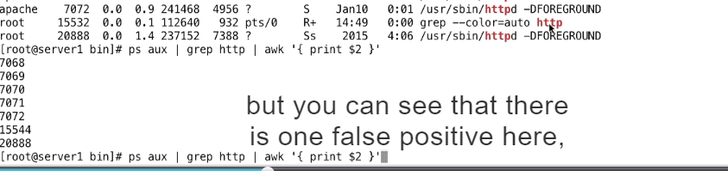







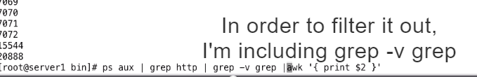

In the command.

Now we have got the list of pids.

Now I have used it in a script

But an important thing is to realize.

If you start developing your own scripts











Now we can verify thiat it is really done

What we wanted it to do

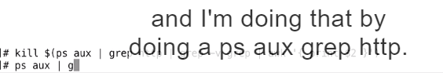

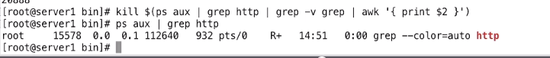

As you can see there is no longer



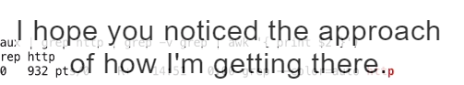



What the exact command is you need to use.

So you can include it in a script

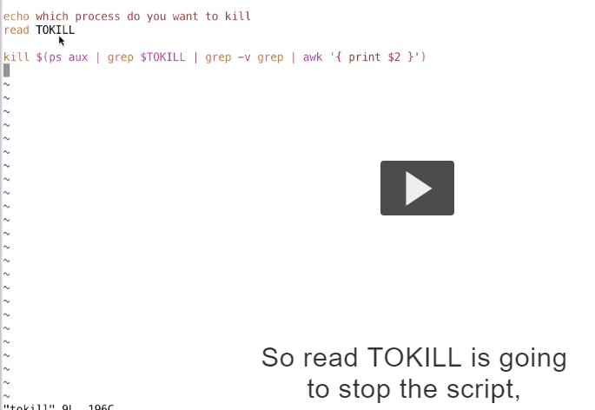





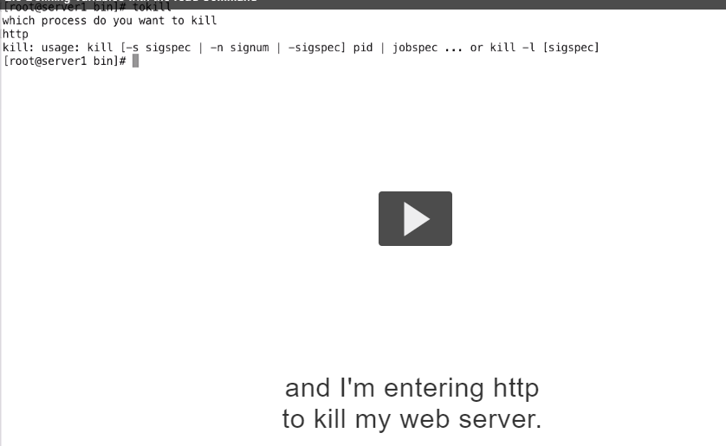

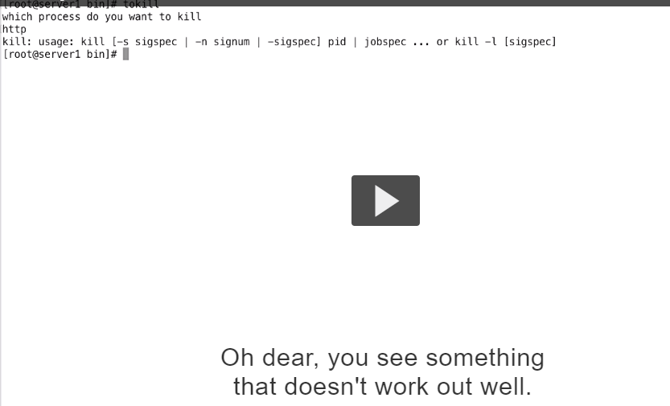





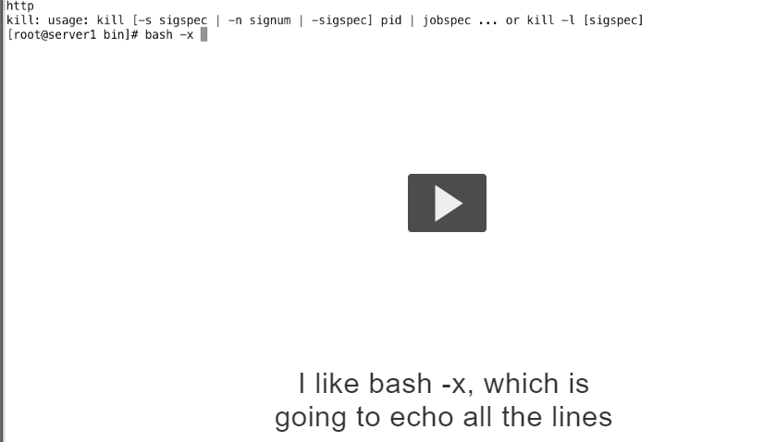

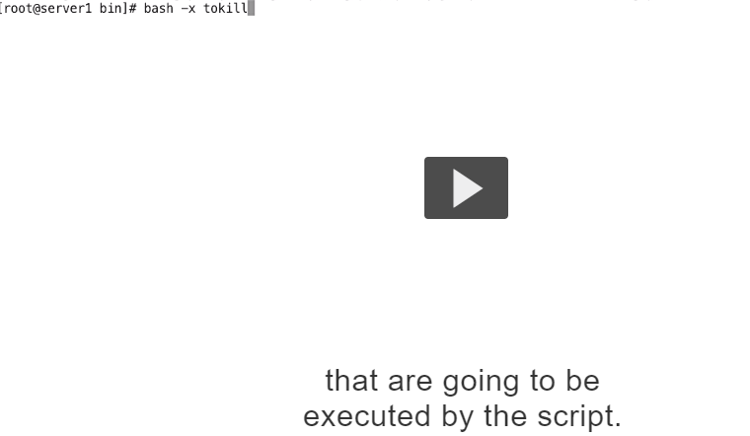

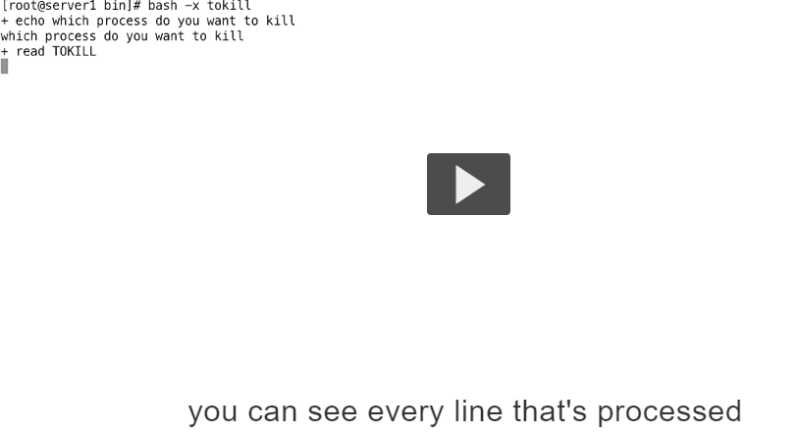





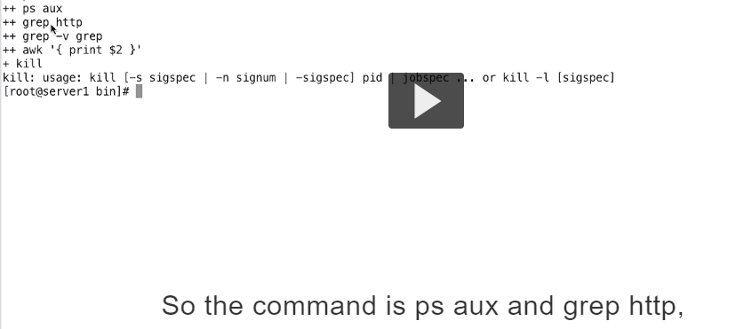

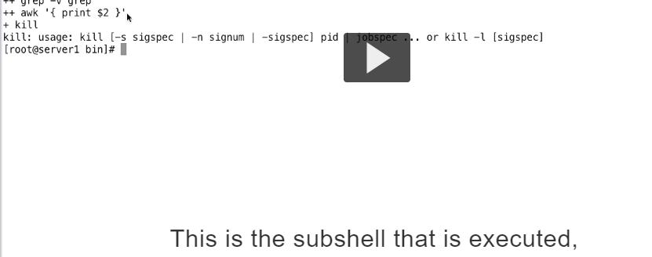

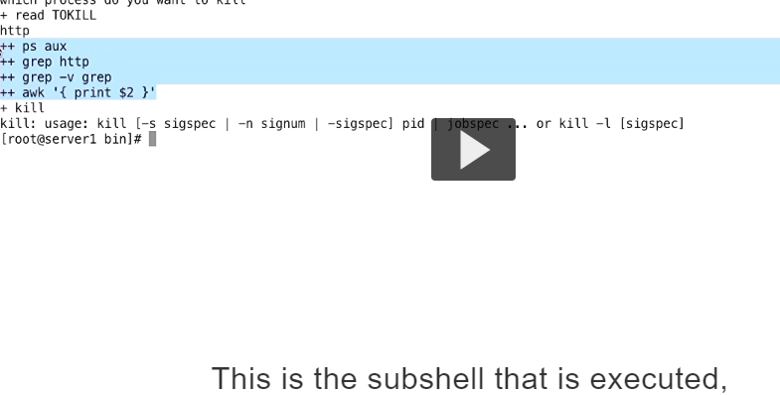



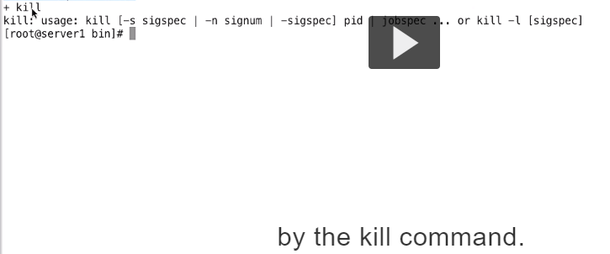



So what is si telling me.its telling me that kill command needs to be used with PID

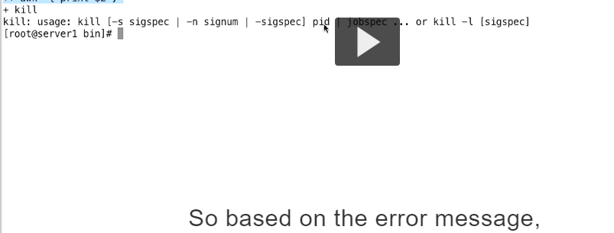

.

Now normally it is the command substitution that is providing a pid.

So what could be wrong here its doesn’t have anything to kill

So to figure out if that is the case

.

So simple solution is 



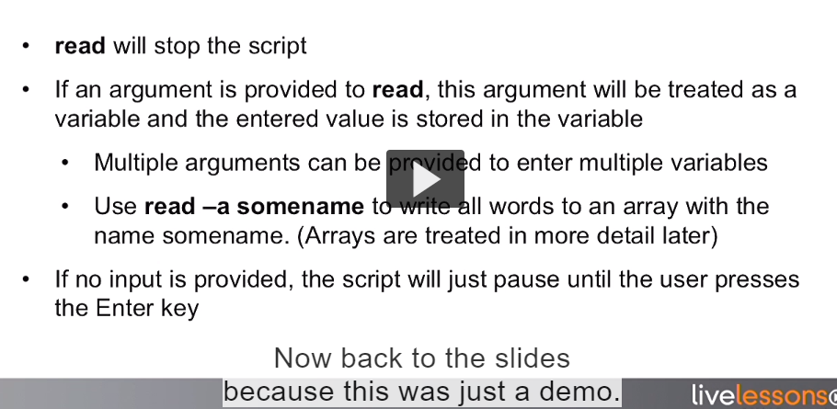

And the script continues with the empty variable.how we can treat a case where no input was provided if input was expected anyway